**Assignment 4.2**

Lab 4: Advanced Prompt Engineering

**Course:** AI Assisted Coding

**Name:** Mohd Aadil Ashraf

**Roll NO.:** 2403A51315

**Instructor:** Dr. Mohammand Ali Shaik

**Date:** 14/08/2025

# Objectives

- Try zero-shot, one-shot, and few-shot prompts in coding.  
- See how output changes with more examples.  
- Learn how prompt strategy affects results.

# Task 1 – Zero-shot

Prompt: Write a Python function to generate Fibonacci sequence up to n terms.

Code (AI Output):

def fibonacci(n):  
 seq = []  
 a, b = 0, 1  
 for i in range(n):  
 seq.append(a)  
 a, b = b, a + b  
 return seq

Output Example:  
fibonacci(5) -> [0, 1, 1, 2, 3]

Screenshot:

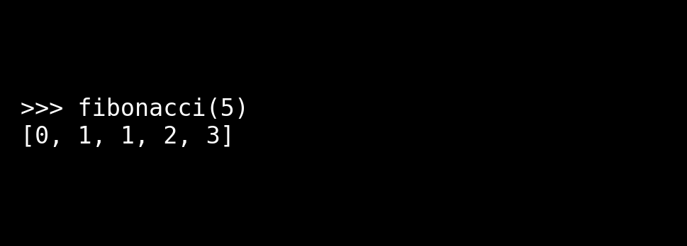

# Task 2 – One-shot

Prompt: Example: Input: 100 → Output: 37.78. Write a function to convert Fahrenheit to Celsius.

Code (AI Output):

def fahrenheit_to_celsius(f):  
 return (f - 32) * 5/9

Output Example:  
fahrenheit_to_celsius(100) -> 37.78

Screenshot:

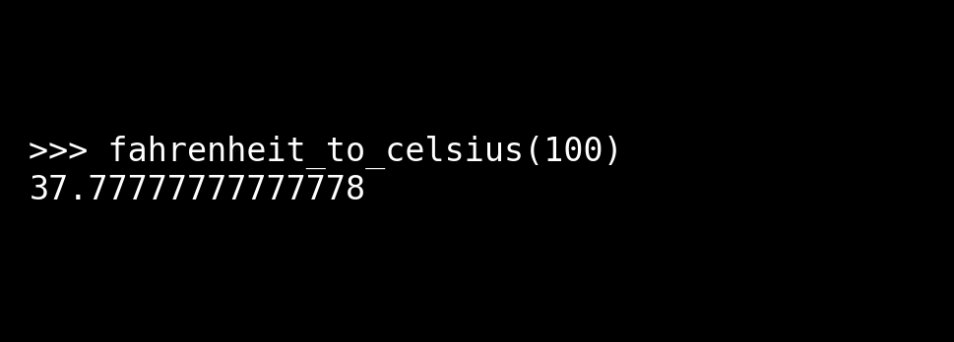

# Task 3 – Few-shot

Prompt Examples:  
- "user@gmail.com" → "gmail.com"  
- "alex@yahoo.com" → "yahoo.com"  
- "sam@outlook.com" → "outlook.com"

Code (AI Output):

def get_domain(email):  
 return email.split("@")[1]

Output Example:  
get_domain("user@gmail.com") -> "gmail.com"

Screenshot:

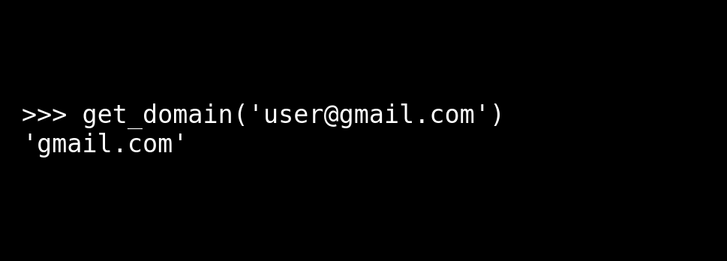

# Task 4 – Compare Zero-shot vs Few-shot

Zero-shot Prompt: Write a function to check if a word is a palindrome (ignore punctuation and case).  
Few-shot Prompt Examples:  
- "Racecar" → True  
- "Madam" → True  
- "Hello" → False

Zero-shot Code:

def is_palindrome(word):  
 clean = "".join(ch.lower() for ch in word if ch.isalnum())  
 return clean == clean[::-1]

Few-shot Code:

def is_palindrome(word):  
 word = word.lower()  
 new = ""  
 for ch in word:  
 if ch.isalnum():  
 new += ch  
 return new == new[::-1]

Reflection: Zero-shot was okay but few-shot gave a clearer and stepwise solution. Examples helped AI make it stricter.

Screenshot:

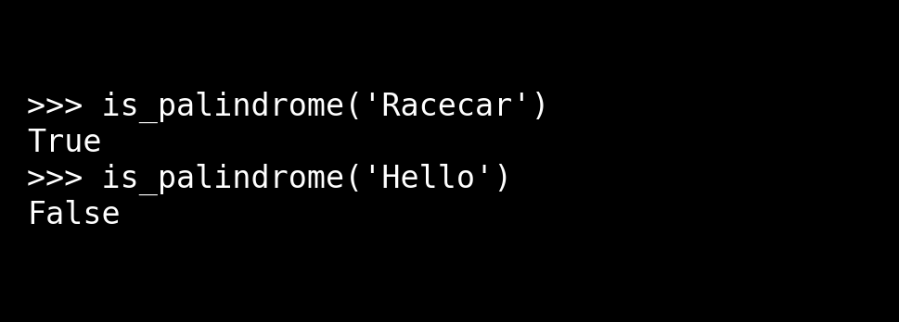

# Task 5 – Few-shot

Prompt Examples:  
- Input: (2, 5, 3) → Output: 5  
- Input: (10, 4, 8) → Output: 10  
- Input: (7, 9, 6) → Output: 9

Code (AI Output):

def max_of_three(a, b, c):  
 if a >= b and a >= c:  
 return a  
 elif b >= a and b >= c:  
 return b  
 else:  
 return c

Output Example:  
max_of_three(2, 5, 3) -> 5

Screenshot:

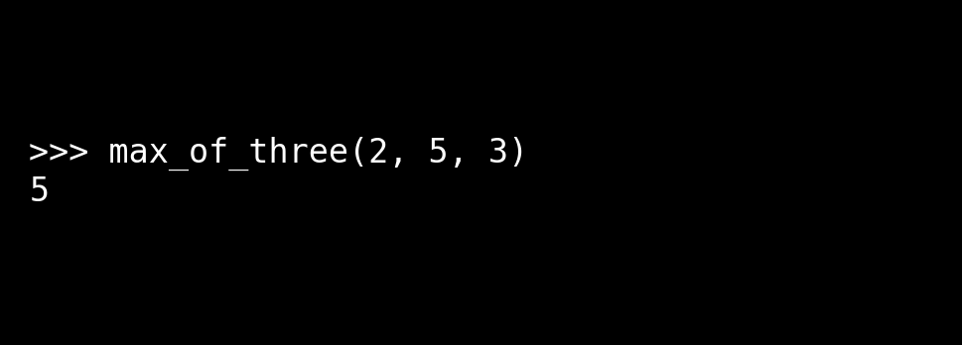

# Conclusion

- Zero-shot: Basic solutions, sometimes too direct.  
- One-shot: Helped guide better with an example.  
- Few-shot: Best, more accurate, and detailed.  
- More examples = more reliable AI outputs.